Place Directorate

Housing and Regeneration

Reply to Resident Engagement Team

Call 01908 253061

E-mail jenna.smith@milton-keynes.gov.uk

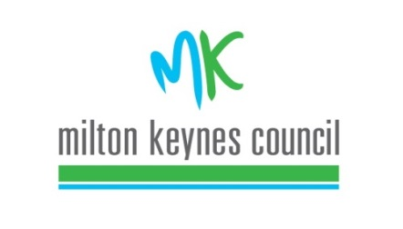

By email

07/07/20

Dear John

**RE: Resident Association health check funding – 2020/2021**

We are delighted to inform you that based on the evidence you submitted, Tinkers Bridge Residents Association have been awarded a **Gold** level of accreditation this year.

As a result, **£775** will be paid into your nominatedbank account within 14 days.

May we take this opportunity to congratulate you on all that you have achieved as a residents association this year.

A certificate accompanies this letter for you to display if you wish.

Should you have any questions regarding this decision, then please contact me within 14 days.

Yours sincerely

Jenna Smith

Resident engagement team – Housing and Regeneration